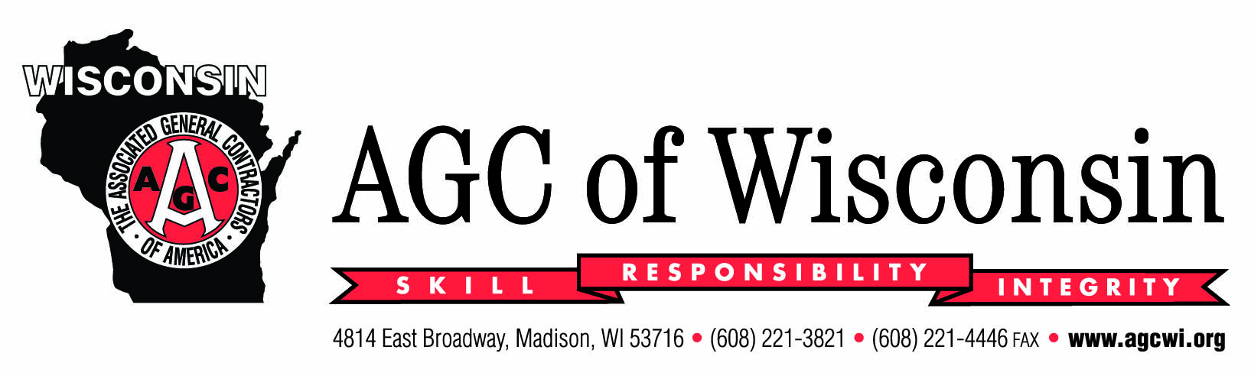

For Immediate Release May 18, 2016
Contact: Jeff Roach
608/221-3821 / jroach@agcwi.org

AGC of Wisconsin Announces New General Counsel – Pat Whiting, J.D.

The AGC of Wisconsin is pleased to announce the hiring of Pat Whiting, J.D. for the AGC General Counsel position effective May 2, 2016. Whiting, a Waunakee (WI) native, is a 2001 graduate of the University of Wisconsin-Madison with a B.A. in Journalism and a 2006 graduate of the University of Minnesota Law School.

From 2007 to 2013, Whiting served as an Assistant Attorney General with the Minnesota Attorney General Office, where he represented the Minnesota Department of Transportation (MNDOT) in eminent domain proceedings for such projects as the Central Corridor Light Rail Transit project and the Highway 52 Lafayette Bridge replacement in St. Paul. He also represented MNDOT in contractual matters with contractors. Since 2013, Whiting has worked for Fredrikson & Byron where he represented the joint initiative of 11 transmission-owning utilities in eminent domain proceedings for the CapX2020 project, which is upgrading and expanding the electric transmission grid in Minnesota, North Dakota, South Dakota and Wisconsin.

Whiting is admitted to practice in Wisconsin, Minnesota, Iowa and North Dakota.

“We are pleased that Pat has accepted the position, and it was unanimous among the Staff and Search Committee that Pat is the right person for the job. In addition to his education and work experiences, Pat’s personality will be a great fit for the membership. We are confident he will continue AGC’s mission of providing excellent legal services for AGC Members”, says 2016 AGC President Matt Faulkner.

For more information about AGC of Wisconsin, visit www.agcwi.org.

About the AGC of Wisconsin
AGC of Wisconsin is one of 64 chapters of the AGC of America, the strongest, oldest and most widely respected construction association in the country. The chapter provides its’ 650+ members and affiliated firms with a comprehensive array of Educational, Safety, Legal, Environmental, Legislative, Public Relations, Labor Relations, Industry Relations and Bidding Information services and is the recognized leader of the construction industry in the State of Wisconsin.

# # #

